No Registration Email Received

In order to receive a Digital Cookie registration, your Girl Scout must be registered for the current Girl Scout year and your council will need to have the correct email address on file for her parent/guardian. If you have opted out of receiving emails from the council, skip to Step 4.


Check your junk/spam/promotions inbox one more time for an email from “Girl Scout Cookies” (email@email.girlscouts.org) with the subject “Register for the Digital Cookie Platform Today”. If you do not see the email there, follow these steps to get registered for Digital Cookie.


Go to digitalcookie.girlscouts.org and click the “Need help to log in” link.
(For best results, use the most up to date web browsers)

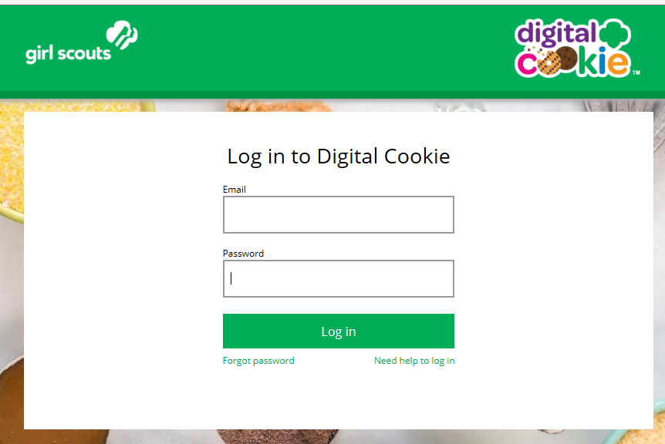

You will get a screen of steps you can use to try and get registered for Digital Cookie.

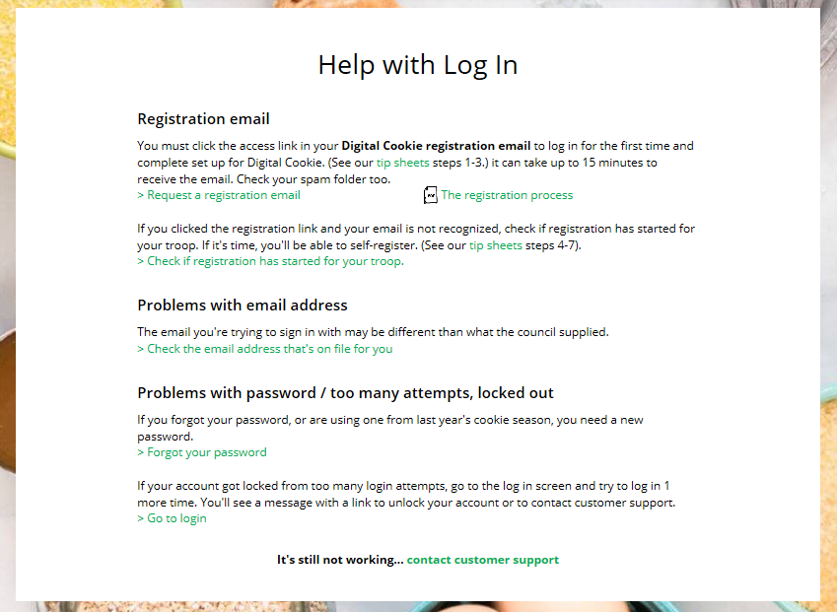


Start by clicking on the “Request a Registration Email” and enter the email address that you used to register your Girl Scout.
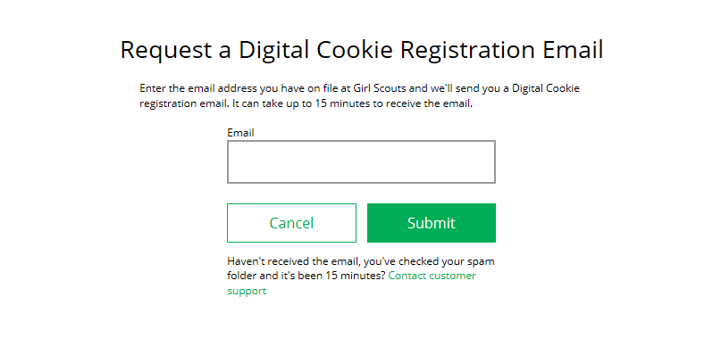
Be sure to add email@email.girlscouts.org to your address book so you get your email!

If your email is in the system, you will get a message letting you know that you have been sent a registration email and you will receive it within 15 minutes.

If you get a red message:

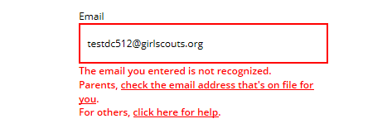
and you think that your Girl Scout is a registered Girl Scout member with your council, you can choose “check the email address that’s on file for you”


You will select your Girl Scout Council

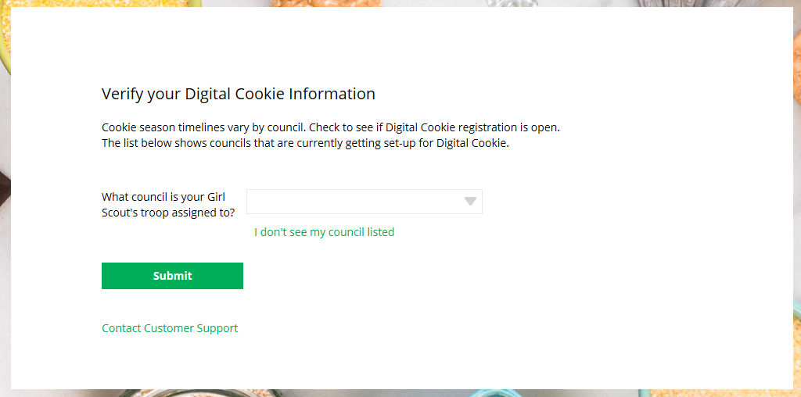


Then enter your Girl Scout’s First and Last Name and her Troop Number.
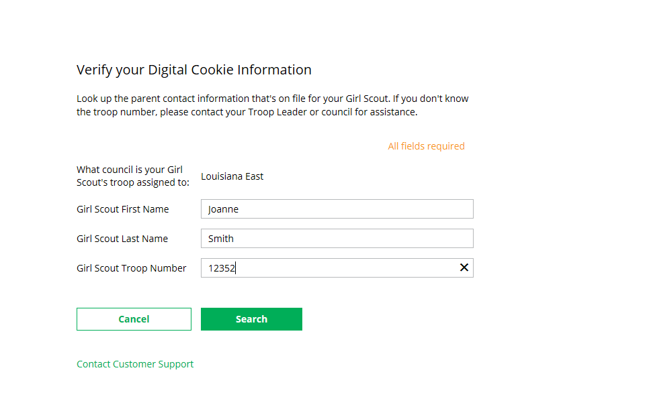

If your Girl Scout’s information is not in the system or not in the system the way you entered it, you will get a message letting you know that you will need to contact your council, Troop Leader or Customer Support for assistance.
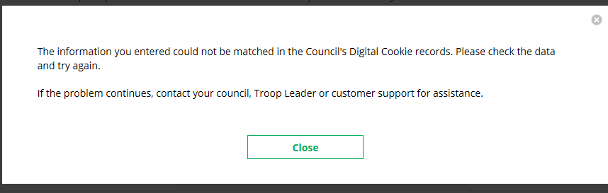


If your Girl Scout and her parent information are loaded into the Digital Cookie system, you will see the information in order to verify that it’s correct.

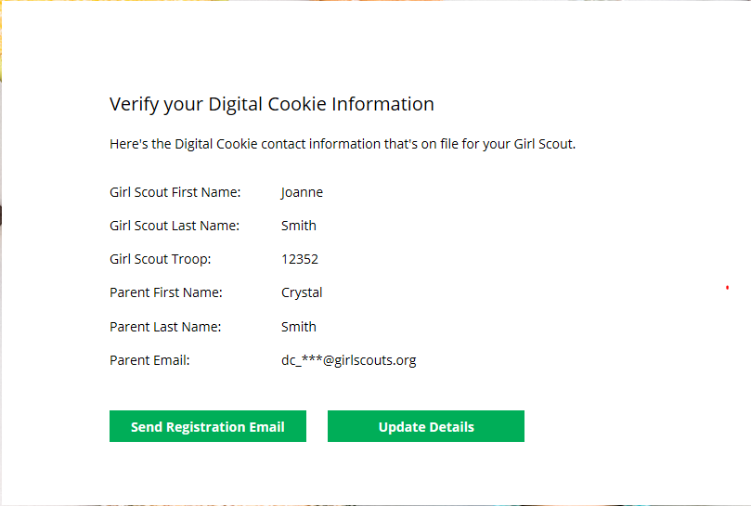
Send Registration Email
Update Details

If the information is correct, you can send yourself a registration email knowing what email address you should use to look for the email.

If the Parent information is incorrect, click on the “Update Details” button. NOTE: if you are also a Cookie Volunteer you will need to update your email address in eBudde.


To update your information, you will need to enter your Girl Scout’s Date of Birth as a security measure, then you can update your name and/or email address.
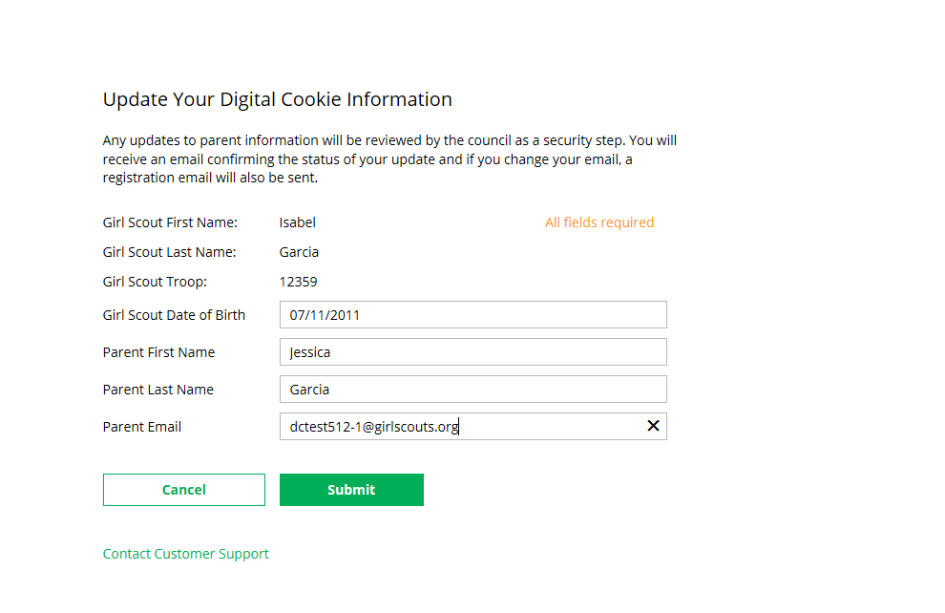
You will get a success message once you submit your changes.
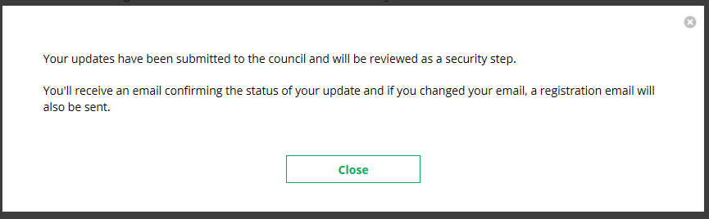

Your council will then review the updates and approve or reject the updates. You will receive an email notification when they have completed that step.


If the Girl Scout is imported but her parent information is not on file, you can add the parent information.

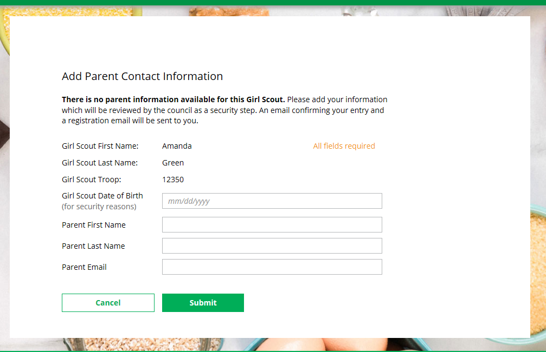

As in step 8, the information will need to be reviewed by the council before your Digital Cookie account will be activated. Once approved, you will receive a registration email and can begin accessing Digital Cookie

